WEEK 7 - ReactJSs

# Cricket App

**Steps:**

1. Create a new React app using the command:

npx create-react-app cricketapp

2. Navigate to the app folder:

cd cricketapp

3. Modify App.js with the following content:

#### Objective:

To display cricket player details using React components and props.

#### Steps:

#### 1.****Initialize App:****

npx create-react-app cricketapp

cd cricketapp

#### 2.Create Player Details Components File:

import React from 'react';

function PlayerDetails(props) {

return (

<div>

<h2>{props.name}</h2>

<p>Runs: {props.runs}</p>

<p>Country: {props.country}</p>

</div>

);

}

export default PlayerDetails;

1. **Modify App.js**

import React from 'react';

import PlayerDetails from './PlayerDetails';

function App() {

return (

<div>

<PlayerDetails name="Virat Kohli" runs={12000} country="India" />

</div>

);

}

export default App;

1. **Run App:**

npm start

1. **Output : Flag= True**

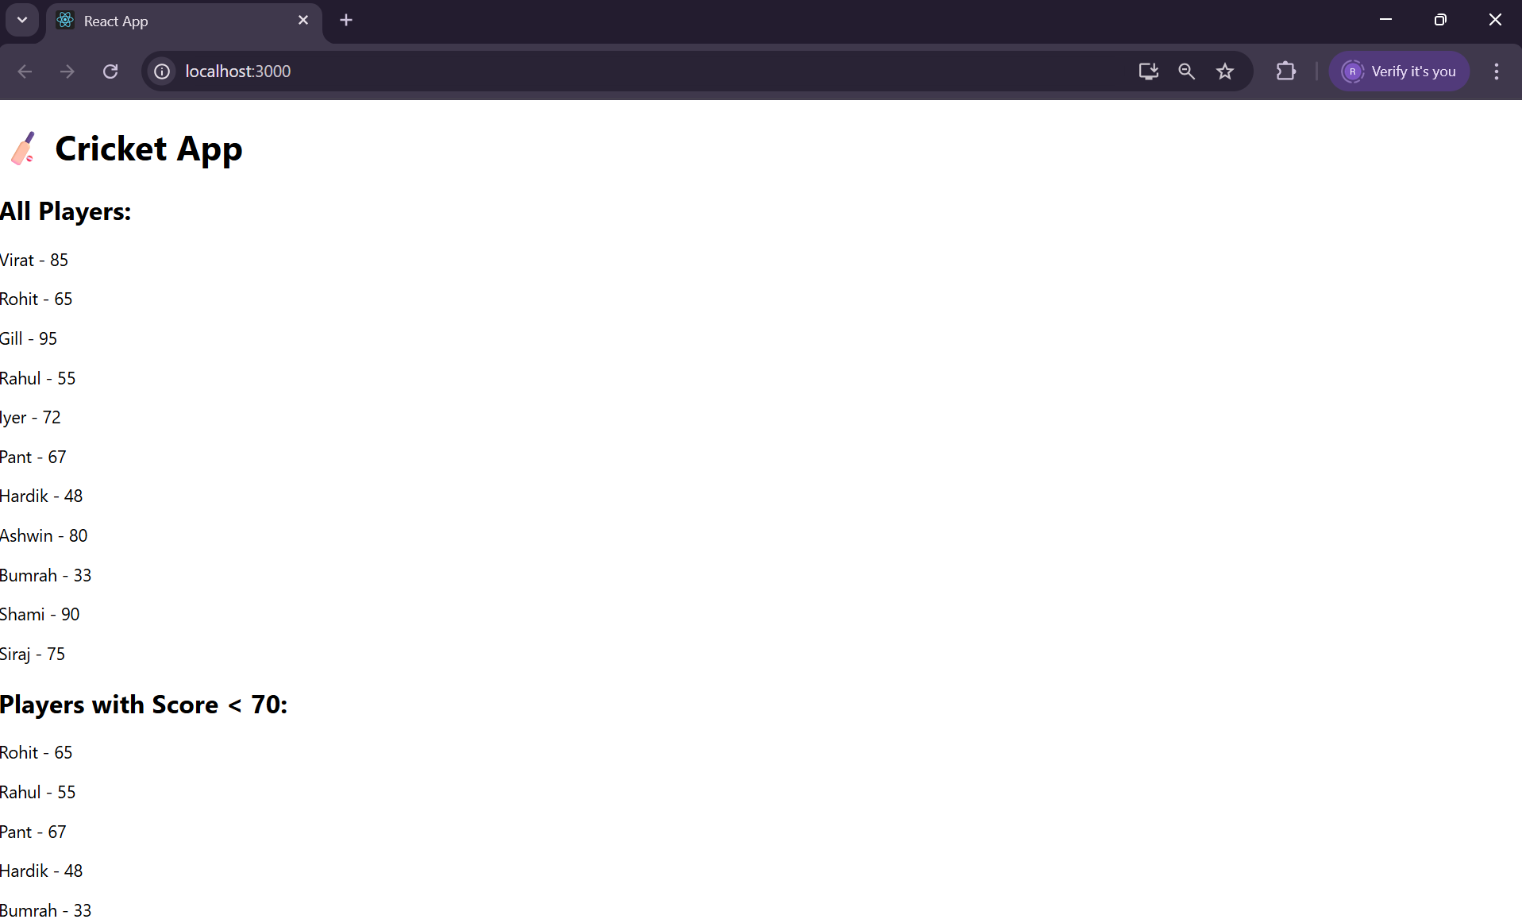

**Flag = False**

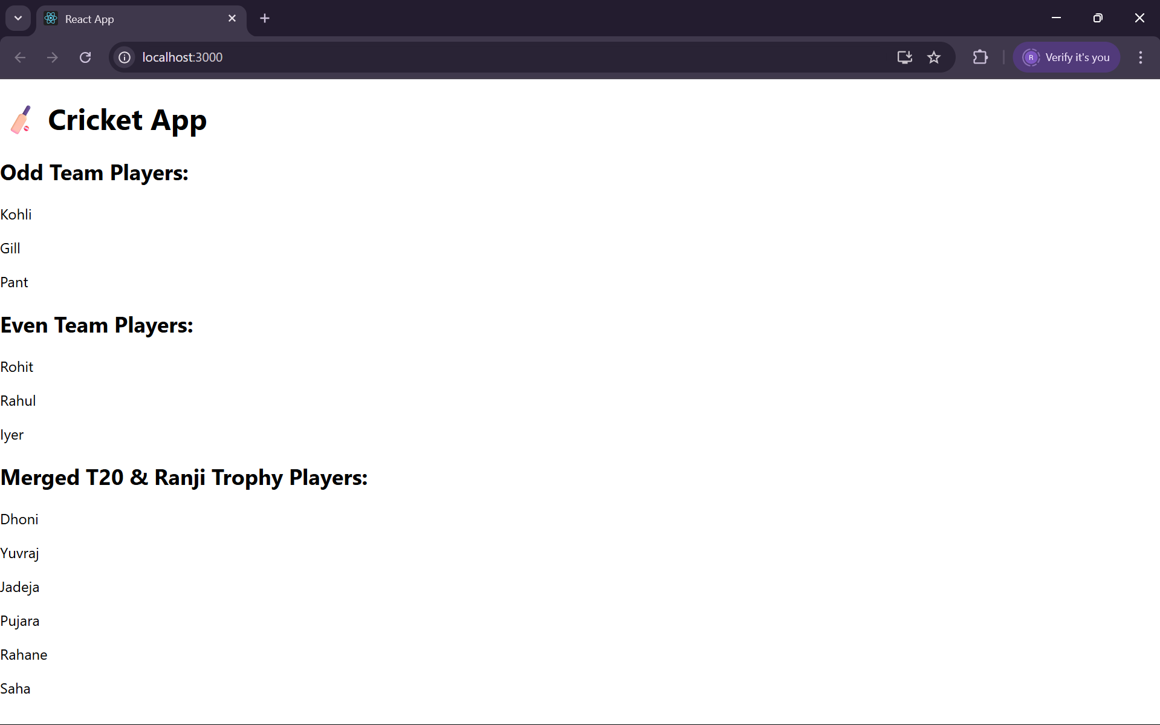

### 10. Office Space Rental App

#### Objective:

To display available office space details using a component.

#### Steps:

1. **Initialize App:**

npx create-react-app officespacerentalapp

cd officespacerentalapp

1. **Create SpaceDetails Components File:**

import React from 'react';

function SpaceDetails({ name, location, price }) {

return (

<div>

<h2>{name}</h2>

<p>Location: {location}</p>

<p>Price: ₹{price}/month</p>

</div>

);

}

export default SpaceDetails;

1. **Modify App.js:**

import React from 'react';

import SpaceDetails from './SpaceDetails';

function App() {

return (

<div>

<SpaceDetails name="Tech Park" location="Chennai" price={50000} />

</div>

);

}

export default App;

1. **Run App:**

npm start

1. **Output:**

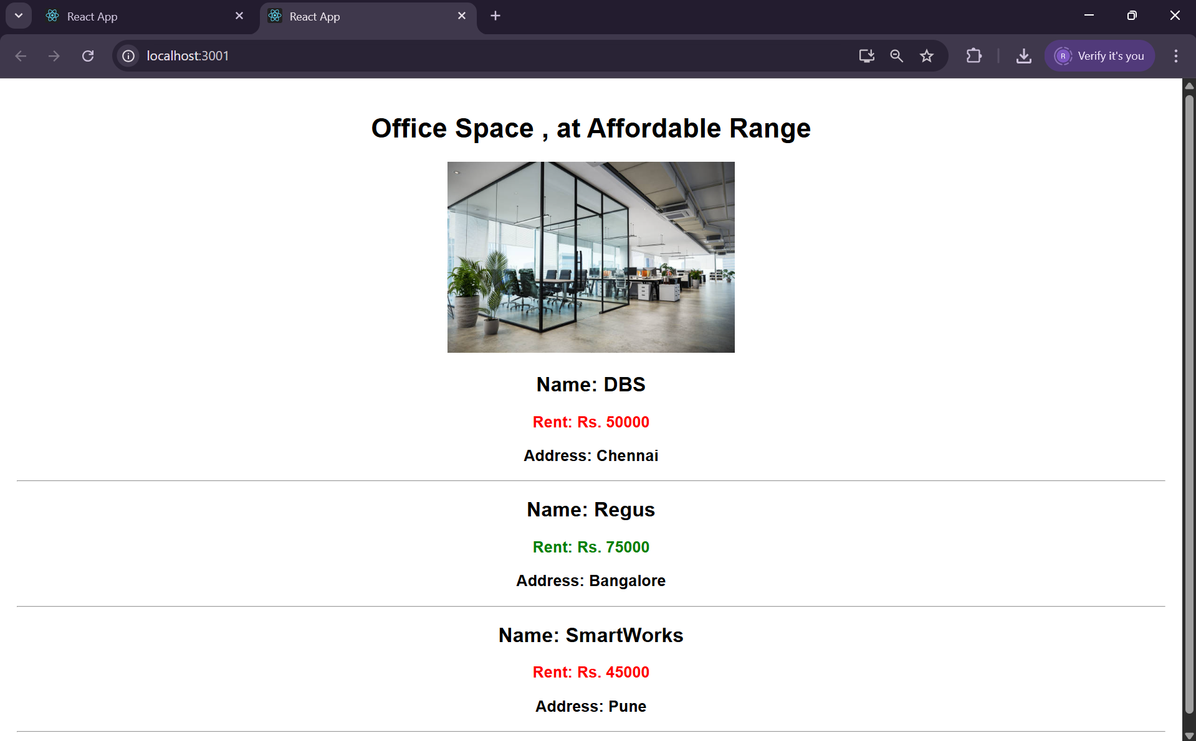

### 11. Event Examples App

#### Objective:

To demonstrate event handling in React.

#### Steps:

1. ****Initialize App:****

**npx create-react-app eventexamplesapp**

**cd eventexamplesapp**

1. ****Create EventButton Component File:****

**import React from 'react';**

**function EventButton() {**

**const handleClick = () => {**

**alert('Button was clicked!');**

**};**

**return <button onClick={handleClick}>Click Me</button>;**

**}**

**export default EventButton;**

1. ****Modify App.js :****

**import React from 'react';**

**import EventButton from './EventButton';**

**function App() {**

**return (**

**<div>**

**<EventButton />**

**</div>**

**);**

**}**

**export default App;**

1. ****Run App:****

**npm start**

1. ****Output:****

****Currency Convertor:****

****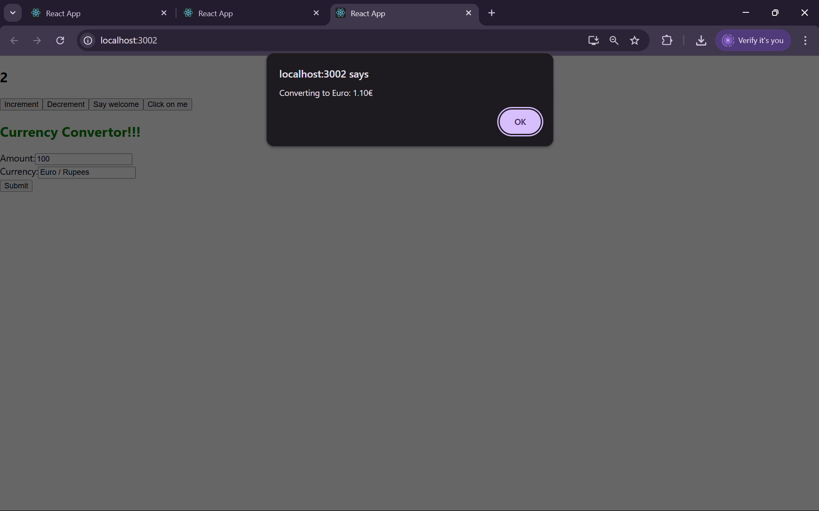****

****Hello Incrementer****

****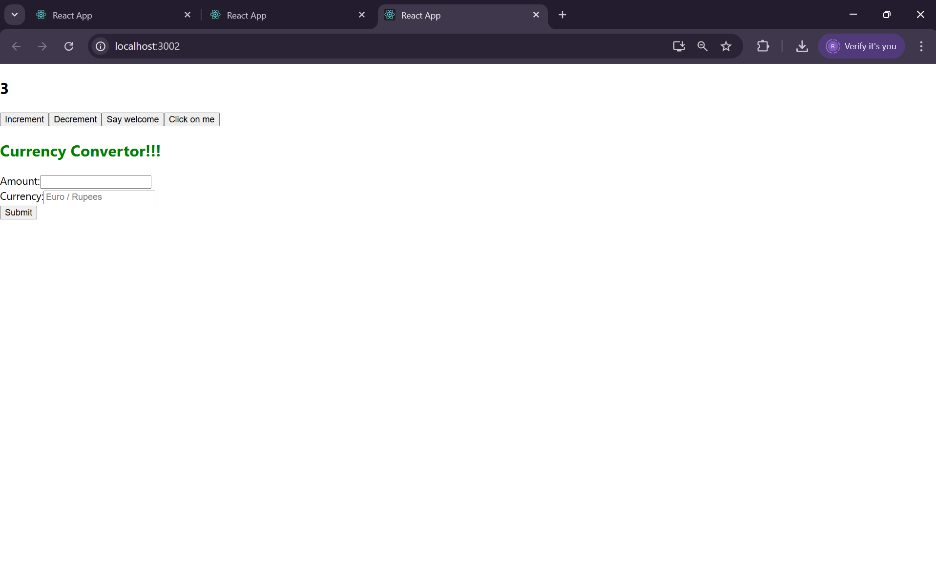****

****Hello Decrementer****

****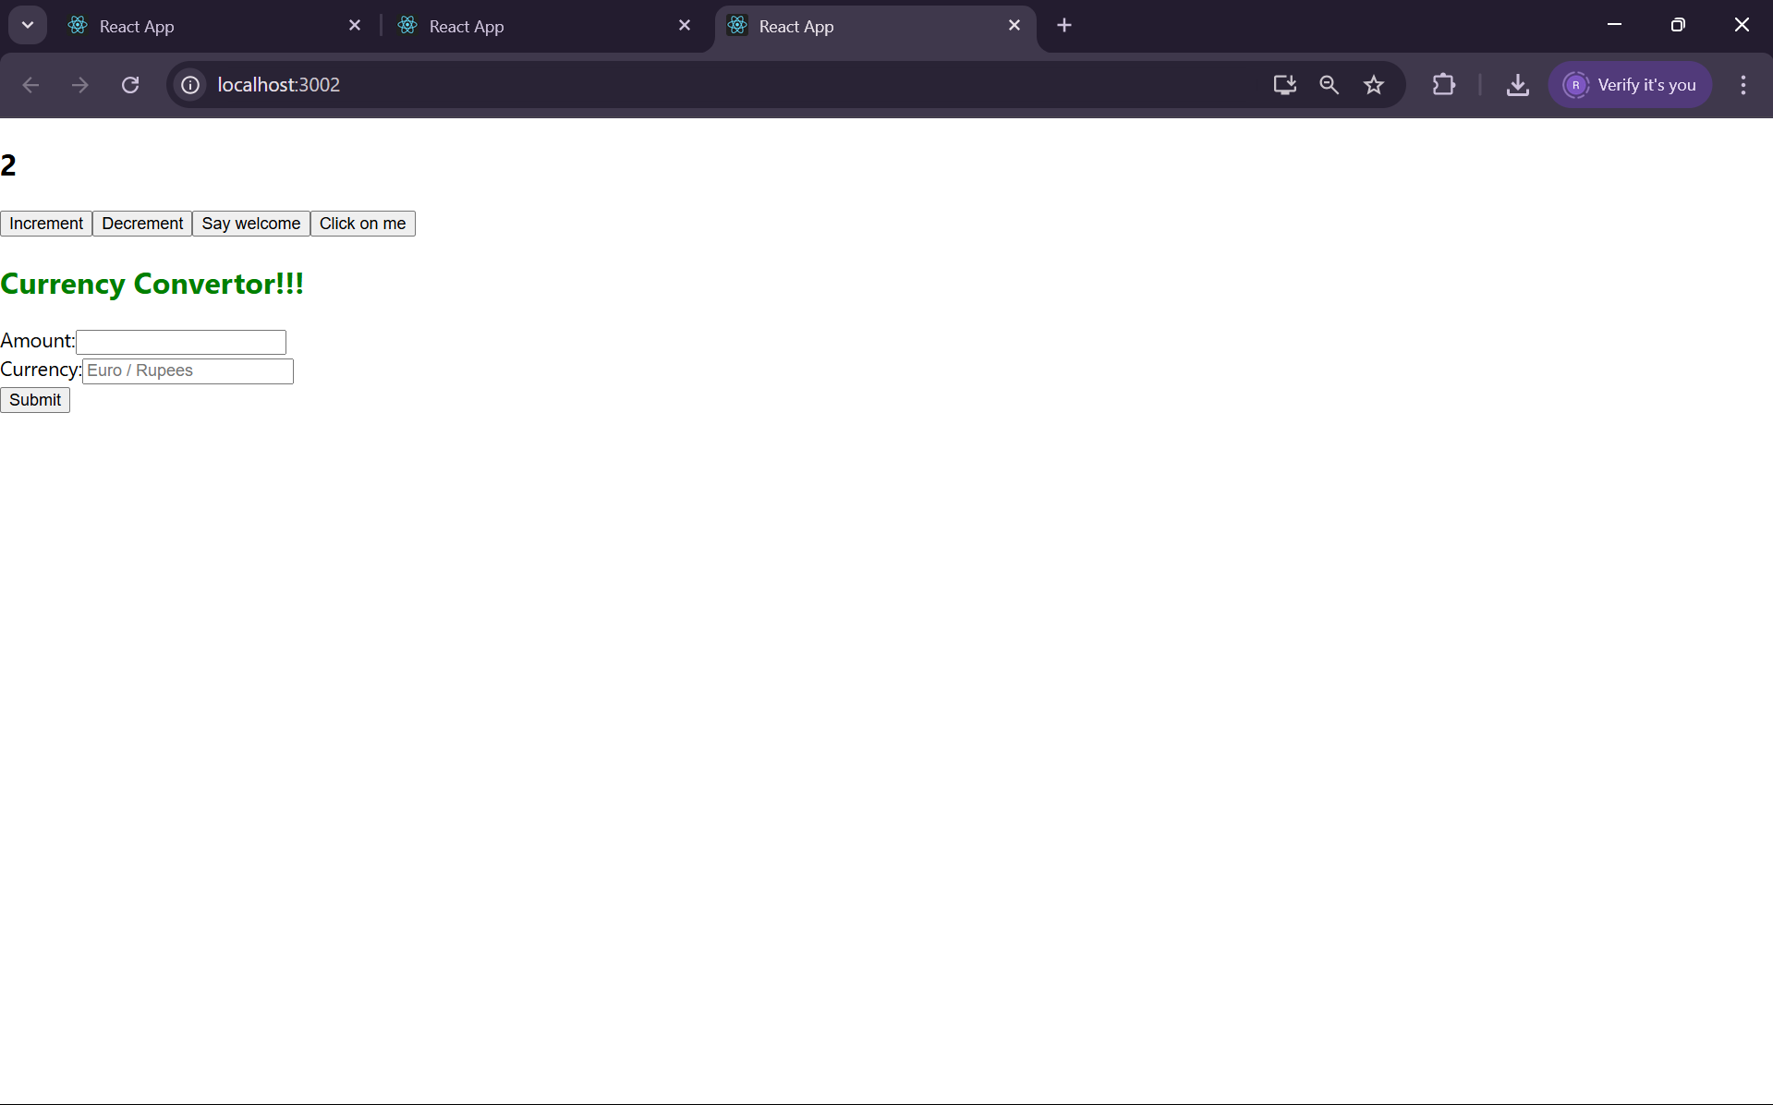****

****Welcome Output****

****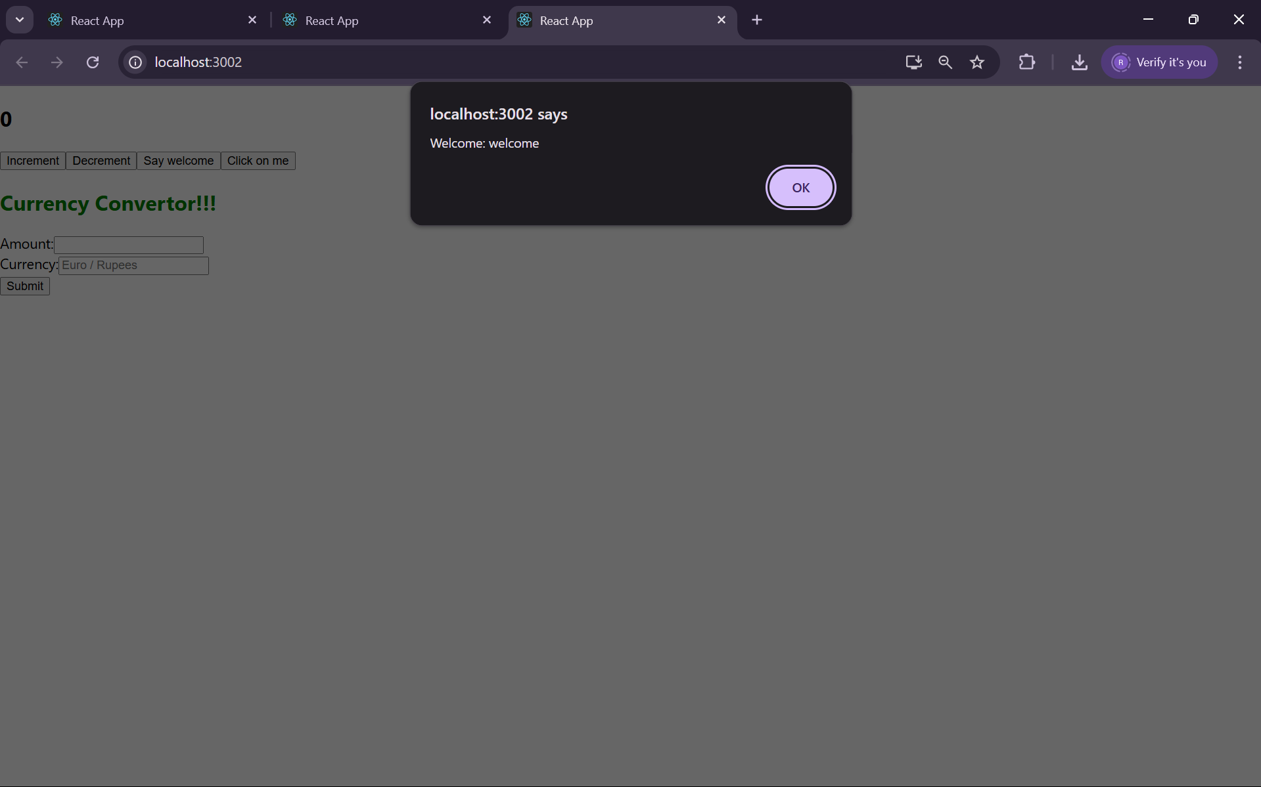****

****I was clicked output****

****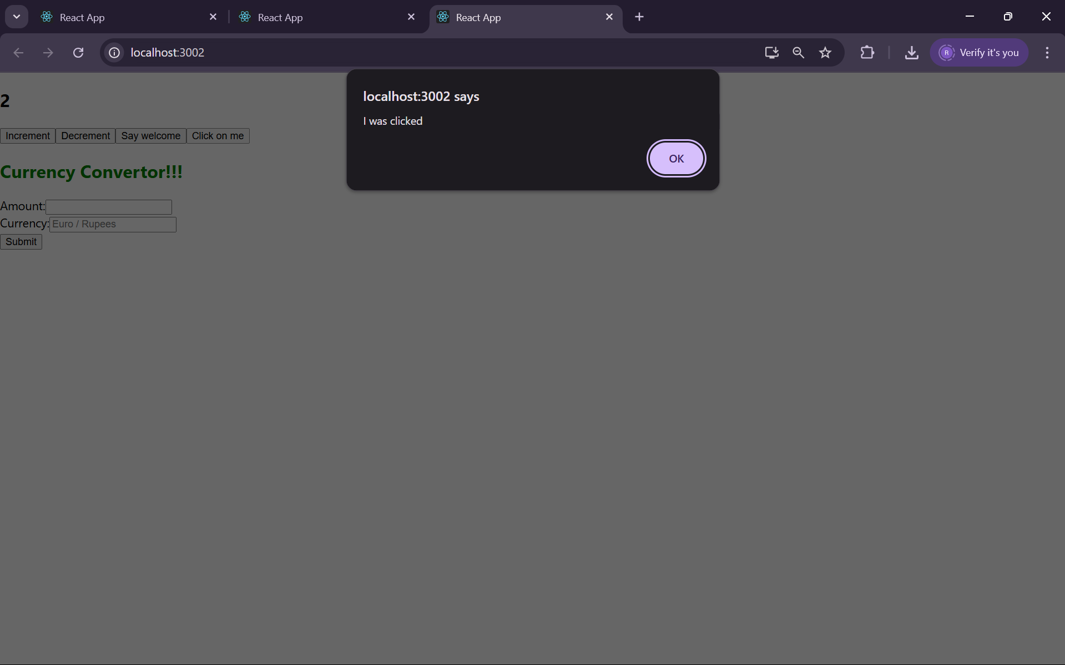****

### 12. Ticket Booking App

#### Objective:

To simulate a basic login and booking interface using conditional rendering.

#### Steps:

#### **Initialize App:**

npx create-react-app ticketbookingapp

cd ticketbookingapp

#### **Create Components:**

**Login.js**

import React from 'react';

function Login({ onLogin }) {

return <button onClick={onLogin}>Login</button>;

}

export default Login;

**Booking.js**

import React from 'react';

function Booking() {

return <h2>Welcome to Ticket Booking</h2>;

}

export default Booking;

1. **Modify App.js:**

import React, { useState } from 'react';

import Login from './Login';

import Booking from './Booking';

function App() {

const [loggedIn, setLoggedIn] = useState(false);

return (

<div>

{loggedIn ? <Booking /> : <Login onLogin={() => setLoggedIn(true)} />}

</div>

);

}

export default App;

1. **Run App:**

npm start

1. **Output:**

**Booking page**

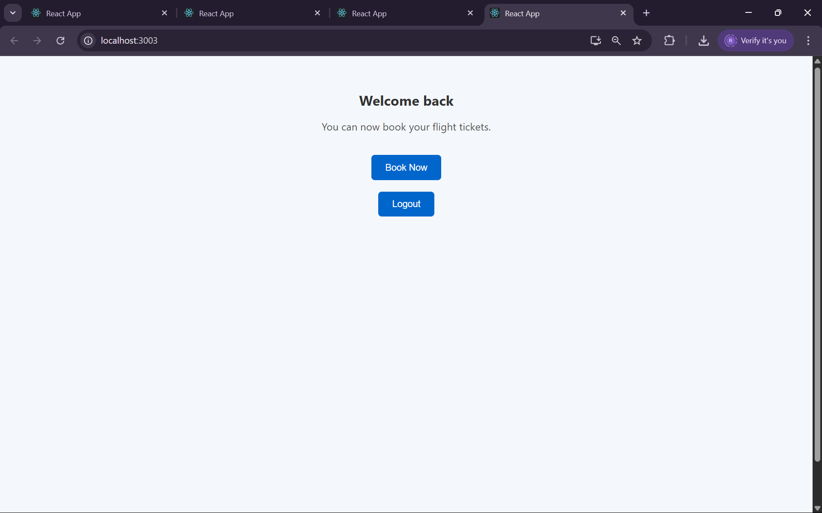

**Login Page**

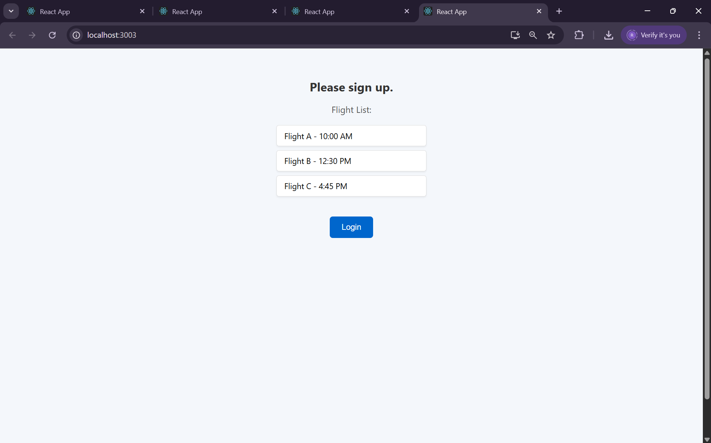

### 13. Blogger App

#### Objective:

To create a blogging page using lists and props.

#### Steps:

#### **Initialize App:**

#### npx create-react-app bloggerapp

#### cd bloggerapp

#### **Create Components:**

import React from 'react';

function BlogList({ blogs }) {

return (

<div>

<h2>Blogs</h2>

<ul>

{blogs.map((blog, index) => (

<li key={index}>{blog.title} by {blog.author}</li>

))}

</ul>

</div>

);

}

export default BlogList;

**Modify App.js:**

import React from 'react';

import BlogList from './BlogList';

function App() {

const blogs = [

{ title: "React Basics", author: "Teja" },

{ title: "Props & State", author: "Teja" }

];

return <BlogList blogs={blogs} />;

}

export default App;

**Run App:**

npm start

**Output:**

